A Free Operating System For A Free Community

What Is Fedora?
Fedora is an operating system and a development platform based on Linux that is free to use, free to modify, free and legal to redistribute, and free from potentially damaging software patent encumbrances.
Fedora is built from the latest technologies from the free software world, and developed by a community of users and developers who are passionate about providing and maintaining the best free software distribution in the world.

What Is Fedora Project?
The Fedora Project is a Red Hat sponsored and community supported open source project. Its goal is the rapid progress of free and open source software and content. The Fedora Project makes use of public forums, open processes, rapid innovation, meritocracy, and transparency in pursuit of the best operating system and platform that free and open source software can provide.
The mindset is Doing the Right Thing. To us, that means providing Free and open source software, at no cost, freely usable, modifiable, redistributable, and unencumbered by software patents.

Fedora Project
http://fedoraproject.org

Fedora Malaysia Ambassadors

Mohd Izhar Firdaus Ismail
izhar@fedoraproject.org

Syamsul Anuar
szaman@fedoraproject.org
Mohd Syafarul Razi
msrazi@fedoraproject.org

Mohd Adli Azaddin Samat
adliazaddin@fedoraproject.org

Mohd Hanafiah Muhamad
hanafiah@fedoraproject.org

Be a contributor! Join Fedora Project!
http://join.fedoraproject.org



http://fedoraproject.org

Fedora is a registered trademark of Red Hat Inc
Linux is a registered trademark of Linus Torvalds
All other marks are the property of their respective owners.
Fedora 11
Fedora 11 "Leonidas" comes on installable LiveCDs, installable DVD or in a 6-CDs set. Packages are selected to cater to a broad spectrum of use, from home and business use, to system administration and software development. No matter who you are, Fedora can provide you with the best free software to meet your needs.
The Desktop
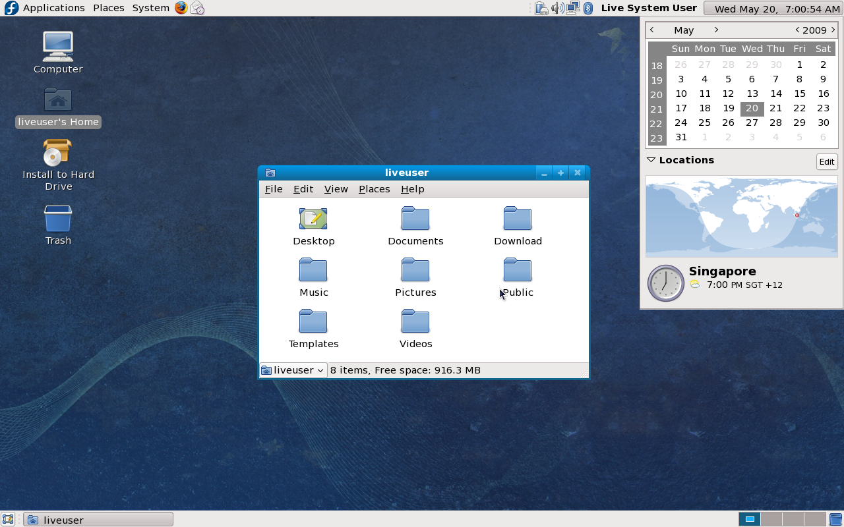
The default Fedora desktop uses GNOME desktop environment. It is easy to use, simple and suitable for everybody, make it normal users, business employees, etc. For the tinkerers, it is not hard to customize the looks of your Fedora desktop. You are free to change the themes to even replace it with a different desktop environment altogether.
If GNOME is not your desktop of choice, KDE and XFCE are readily available.
Fedora Repositories
The packages you get from the installation media is not Everything!. The Fedora repositories includes a gigantic collection of applications which you can download easily using the Add/Remove Software tool.
OpenOffice
OpenOffice.org is a multiplatform and multilingual open source office suite. It have everything you need for productivity in your business, studies and everyday tasks
Fedora 11 New Features
Volume Control
Currently, people using Fedora have to go through many levels of mixers to properly set up sound sources. These are all exposed in the volume control on the desktop, making for a very confusing user experience. PulseAudio allows us to unify the volume controls in one interface that makes setting up sound easier and more pain-free.
Intel, ATI and Nvidia Kernel Modesetting
Fedora 10 provided the first steps by a major distribution into using the kernel modesetting (KMS) feature to speed up graphical boot. In Fedora 11, this work is extended to include many more video cards, including Intel and Nvidia, and additional ATI as well. Although not fully complete, we have increased enormously the video card coverage of the KMS feature, with more to come.
iBus Input Method System
ibus has been rewritten in C and provides a simple clean input method framework with support for input of Asian and other languages. It is able to load and unload input methods from its configuration setup during a desktop session to avoid the need together with imsettings for having to restart the desktop to activate or deactivate input method support.
Filesystem
Ext4 is the now the default FS in Fedora. The ext4 filesystem has more features and generally better performance than ext3. Ext4 enables support for volumes as large as 1 exabyte (over 1,000,000 terabytes). Extents, which are ranges of contiguous physical blocks are introduced to improve large file performance and reducing fragmentation.
Getting Fedora
Fedora can be acquired easily through bittorrent, our public mirrors, OEM, local retail vendors or from our free media project. Visit these links for more details.
http://torrent.fedoraproject.org/
http://fedoraproject.org/wiki/Distribution
Getting Support
Support from Fedora comes in various forms. Website, web forums, public IRC channels and mailing list are some of it.
- Official Documentations
http://docs.fedoraproject.org/
- Community forums
http://fedoraforum.org
- Mailing List
http://fedoraproject.org/wiki/Communicate.
- IRC channel
#fedora @ irc.freenode.net
Our local Fedora community can be reached at
- IRC channel
#fedora-my @ irc.freenode.net
- Mailing List
https://www.redhat.com/mailman/listinfo/fedora-my-list

